Fig. S1 Screening of transgenic plants using the LibertyLink strip (A) and PCR detection (B, C, and D). M, DNA marker (2K); Ctl+, positive control; Nt, non-transformed plants P03; 1–5, T₀ transgenic plants.
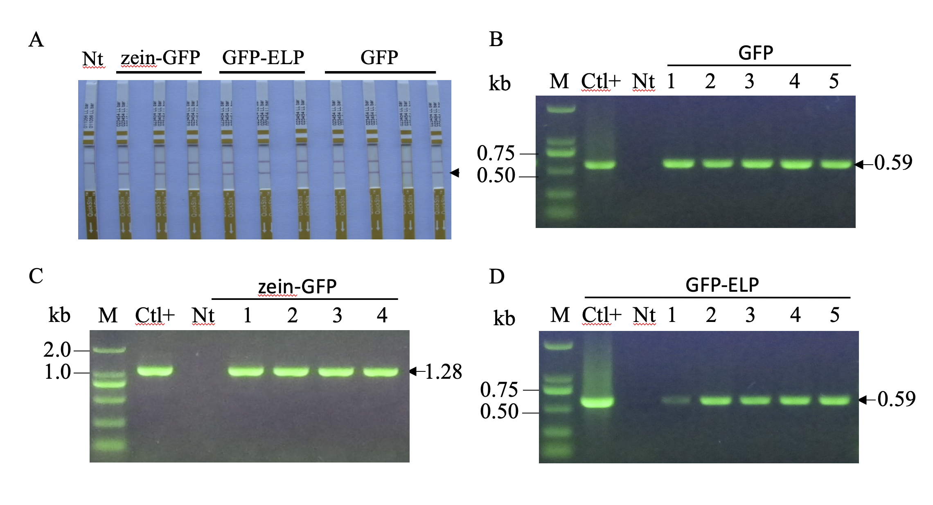

Table S1 Accumulation of the recombinant proteins in immature and mature soybean seeds (%TSP)
Lines | Recombinant protein in immature seeds | Average | Recombinant protein in mature seeds | Average
DF-4 | 0.07 ± 0.03 |  | 0.44 ± 0.11
DF-8 | 0.08 ± 0.03 | 0.07 | 0.57 ± 0.18 | 0.46
DF-43 | 0.06 ± 0.01 |  | 0.37 ± 0.14
DG-12 | 0.84 ± 0.16** |  | 1.42 ± 0.31**
DG-44 | 1.20 ± 0.22** | 0.99 | 2.08 ± 0.21** | 1.8
DG-49 | 0.95 ± 0.07** |  | 1.91 ± 0.16 **
DE-1 | 0.30 ± 0.12** |  | 0.88 ± 0.19**
DE-9 | 0.25 ± 0.07** | 0.29 | 0.79 ± 0.06** | 0.84
DE-28 | 0.34 ± 0.09** |  | 0.85 ± 0.18**

